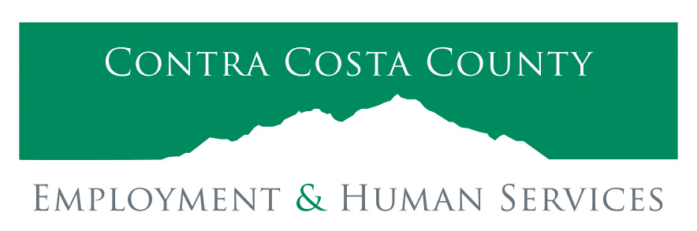

Aging & Adult Services

PUBLIC MEETING ANNOUNCEMENT

Public Meeting for Contra Costa Agencies Serving Older Persons and Interested Community Members on Wednesday, March 20, 2024

The Contra Costa County Area Agency on Aging (AAA) will be holding a public hearing on March 20, 2024 beginning at 10 a.m. to present Contra Costa County’s draft 2024-2028 Area Plan. The hearing will be held in-person at 500 Ellinwood Way, Board Room A/B, Pleasant Hill, CA 94523 and via Zoom at:
https://cccounty-us.zoom.us/j/89311212374?pwd=Zm6SXhWaAo9vJuha6dfuhsOnzGuOX5.1 Password: 602444

The Public Hearing provides an opportunity for the public to be informed about and comment on the draft 2024-2028 Area Plan, which discusses the needs of older adults, persons with disabilities, and family caregivers in Contra Costa and identifies the strategies to address these concerns. Public members, service providers, and other interested individuals are encouraged to attend and provide input.

Federal law and regulations require AAAs to conduct business so as not to discriminate on the basis of language spoken or disability. The meeting place is accessible, and the meeting will be conducted in English. Individuals who need accommodation or language interpretation, please contact Glenda Pacha at (925) 655-0772 as soon as possible, so suitable arrangements can be made. Everyone is welcome and encouraged to attend.

A copy of the draft 2024-2028 Area Plan will be available on March 13, 2024 at:
https://ehsd.org/elderly-disabled/area-agency-on-aging/

