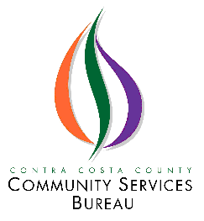
In-Person
6-21-23
Policy Council
Meeting
Canceled

We’ll meet on 8-16-23.

Thank you so much for your understanding!

For questions or concerns, please contact Ana Araujo at (925) 864-0837

