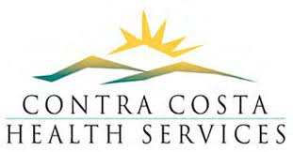
Covid 19 - Food Delivery Volunteer Opportunity
Duties and Schedules:
Noon to 2:00 PM - Volunteer will serve as a Loader only
Noon to 5:00 PM – Volunteer will serve as a Loader PLUS as a Ride-Along Box Unloader
Need to report by 11:45 AM
Possible days of the week – Monday through Thursday (one or more days each week)
Tasks:
- Lift and carry an approximate 22-pound box of food to each residential door or porch
- Deliver up to 25 boxes each shift
- Safely enter and exit delivery vehicle
- Proper use of a cart or dolly
- No person to person contact
- One shift per day per volunteer
- Assignment begins the week of May 25th – ongoing
Sites:
Concord* – Seneca 3200 Clayton Road, Concord, CA 94519
*County Connection offered volunteer transportation from home to the site if needed, for volunteers who live within County Connection’s service area.
El Sobrante – Seneca Catalyst – 1060 Manor Road, El Sobrante, CA 94803
Equipment:
Tools – hand truck, cloth mask and bus drivers will be provided
Attire:
Uniform / Dress Code – sturdy shoes, comfortable clothing that allows for proper lifting techniques, own mask if you prefer to use your own vs. one being issued
Volunteer Wellness and Training:
Breaks, Injury and Illness protocols, nutrition, weather, just in time instructions
Special Qualifications: must have background clearance.
Registration: Please email your interest and any questions to Shannon.Ladner-Beasley@cchealth.org
Volunteers can register for one day a week or multiple days depending on availability Covid19VolOpp

