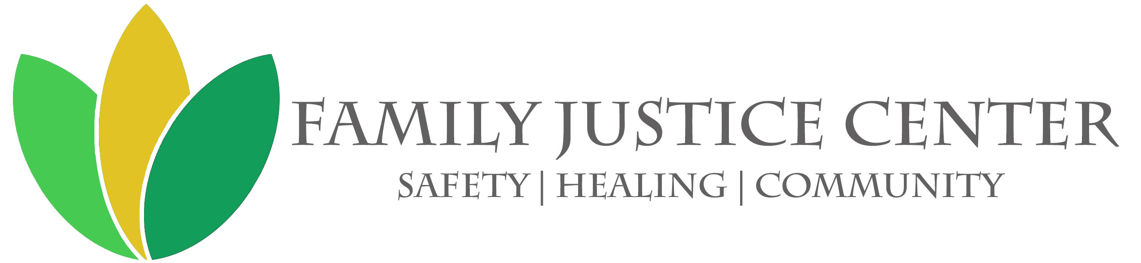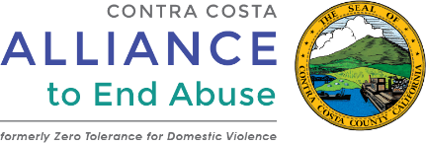

Media Contact:
Tish Gallegos
(925) 433-1266
tgallegos@ehsd.cccounty.us

FOR IMMEDIATE RELEASE:

First in Nation: Countywide Support Network to End Violence Opens New Center
Support, Hope, Safety and Healing through a Single Door for Victims of Violence
ANTIOCH, Calif. (September 27, 2019) – During an abusive relationship with her husband, Nancy reached out for help at one of Contra Costa County’s Family Justice Centers (FJC). There, she received healing therapy and legal services that led to holding her husband accountable and a getting on a path toward healing and self-sufficiency. Otherwise, she says she may not have lived to tell her story.
Nancy and other survivors will be among those celebrating the grand opening of the County’s newest East County Family Justice Center on Friday, September 27, 2019 from 12 noon to 2 p.m. at 3501 Lone Tree Way in Antioch, CA. The Center will serve residents in Oakley, Bethel Island, Brentwood, Pittsburg, Discovery Bay and other East County locations.
“This has been a long time coming. We received nearly $200,000 in grants to establish this badly needed support center,” explained Susun Kim, Family Justice Center Executive Director. “Finally, we can serve our clients in the East County who are affected by domestic violence, child abuse, sexual assault, elder abuse and human trafficking.”

In 2018, Contra Costa County had nearly 11,000 domestic violence calls to its crisis center; more than 4,000 reports of elder abuse; thirty-six thousand child abuse hotline calls led to 833 substantiated cases of child abuse, 1,500 sexual assault victims and 136 human trafficking victims.

“The Contra Costa Family Justice Centers are the first in the nation to have one county-wide network of support so victims get the same type and quality of services, regardless of where they live,” said Alex Madsen, Division Manager of the Contra Costa Alliance to End Abuse. The Alliance is an initiative of the Contra Costa County Board of Supervisors and a division of the Employment & Human Services Department.
Expanding Services to East County
The Family Justice Center is a warm and welcoming one-stop center for children, youth and adults affected by domestic violence, sexual assault, child abuse, elder abuse and human trafficking. By locating many service providers in one place, the Family Justice Center helps people in crisis find hope, safety, and healing through a single door. The Family Justice Center operates two other centers, located in Richmond and Concord, making the East County Center the third in the area.

At the East County Center, clients will have access to a broad spectrum of services with 20 partners on-site. Many of these partners will be available at the opening event to speak with the media about their services for victims of violence. The single location allows agencies to serve and advocate for clients quickly and directly, significantly reducing the trauma associated with multiple interviews or assessments, especially for children. This also benefits the community by eliminating redundancies, improving coordination, and streamlining services to offer immediate help.
The East County Family Justice Center is a 3,300-square-foot facility. Funding included $80,000 toward tenant improvements, a one-time grant of $90,000 from Kaiser Permanente Diablo Valley Community Benefit, a $75,000 grant from Lesher Foundation to cover expenses such as telecommunication systems, furniture/furnishings/equipment, etc., and an $11,000 Hedco Foundation grant to purchase computers.

Available Speakers of Survival
- Marisol is a domestic abuse victim who created Project Connect and has been working as a Navigation Assistant at the Family Justice Center for three years. Project Connect is a survivor-led, community-building circle that engages residents to learn and problem solve together. The goal is to do this while sharing resources and responsibility. In the first half of this year, Project Connect included 127 adults and 57 children.
- Nancy reached out to the Family Justice Center during a verbally and physically abusive relationship. She received extensive Navigation services at the Central Center including legal services that led to the incarceration of her husband. The Center’s therapy sessions put her back on the road to recover, and she is now a passionate voice for victims of domestic violence.
- Janell has experienced domestic violence and stalking. She connected with the Center and was able to set up a safety plan. She later learned about the Community Fellowship Program and applied. “When you come from a place where all of your power is stripped from you, and you come to a place that reminds you of the power you have to create something new… something greater than yourself… that is where I want to be."
- Gloria suffered many forms of abuse, including rape by the father of her son. She participated in our Women INspired to Grow and Succeed Program, and will join our Community Fellowship program (leadership development) this year.
Art Contest Winners on Display
The Family Justice Center hosted an art contest for young artists in middle and high school, and the winners’ works will be on display at the grand opening event. The young artists each submitted an 11”x14” work to encompass the feeling of “safety,” “healing,” or “community.”

Family Justice Center
The Family Justice Centers, with locations in Richmond, Concord and Antioch, bring hope and healing to people who have experienced domestic violence, sexual assault, elder abuse, child abuse, stalking, or human trafficking. The Center is a model of collaboration among various government and nonprofit agencies that creates far-reaching positive results for our entire community. The Center relies on support to help create safer and healthier communities for all. Visit Family Justice Center for more information.

Contra Costa Alliance to End Abuse
The Contra Costa Alliance to End Abuse, a public/private partnership founded by the Contra Costa County Board of Supervisors, and led by a division of the Employment & Human Services Department (EHSD), provides financial support and thought leadership to the Family Justice Center. The Alliance is committed to ending interpersonal violence in Contra Costa County, and works with a wide range of agencies to put in place a variety of programs, projects and strategies to help keep community members out of harm’s way. Our goal is to propel a systematic change that ends all types of interpersonal violence, whether it be domestic and sexual violence or human trafficking. We are dedicated to keeping the residents of Contra Costa County safe through the development and implementation of innovative services and activities. To learn more, visit The Alliance website.
# # #

