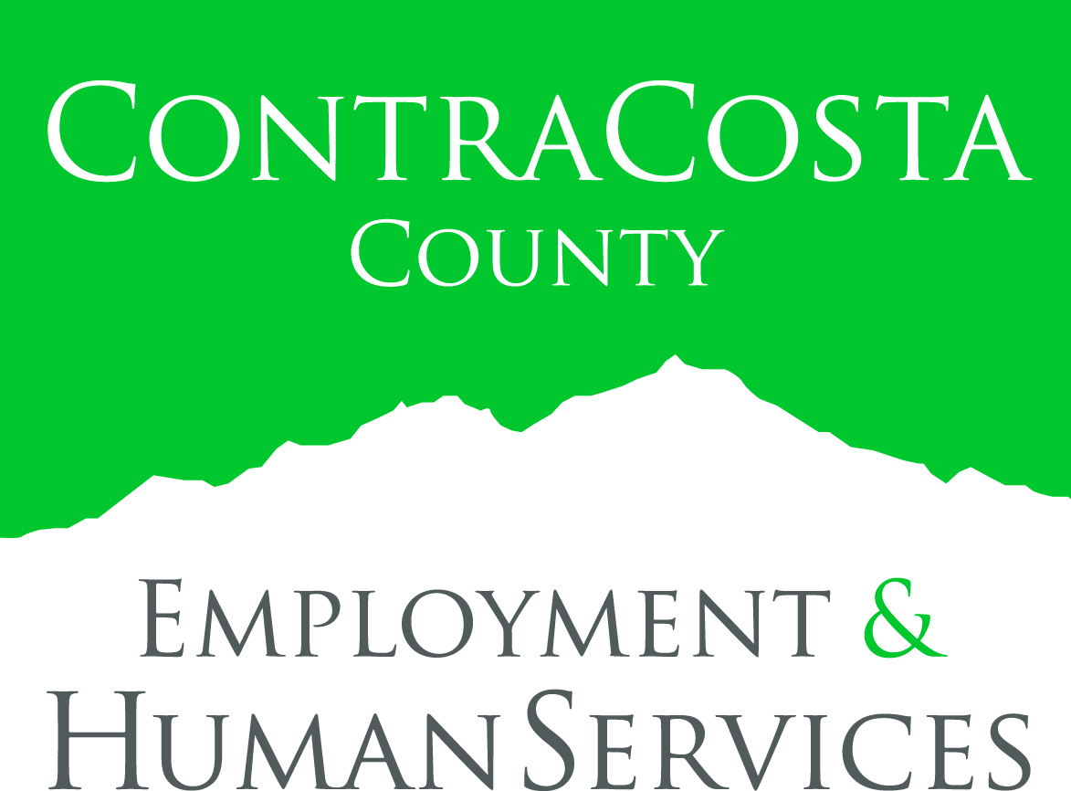

FOR IMMEDIATE RELEASE:
The White House Invites Contra Costa County Customer Centered Design Team to Present Project to Improve Access to Resources for Inmates upon Release
EHSD’s Workforce Development Board Led Partnership with Probation, Office of Education and Volunteers of America in U.S. Department of Labor’s Customer-Centered Design Challenge
MARTINEZ, Calif. (September 15, 2016) – The Contra Costa County Employment & Human Services Department (EHSD) has announced that a team led by the Workforce Development Board of Contra Costa County (WDBCCC) will participate in the U.S. Department of Labor’s (DOL) Customer-Centered Design (CCD) Learning Exchange & Celebration at the White House. The Contra Costa team is one of 15 from across the country to earn a highly coveted invitation to partake in the initiative’s recognition event in our nation’s capital as a result of submitting a winning proposal to improve access to resources for inmates upon release. Winning teams will have the opportunity to showcase their customer-centered design approaches to White House staff members and federal agency leaders, share ideas, and celebrate at an all-day event on Monday, September 19.
“The WDBCCC spearheaded a unique partnership to come up with a pilot tool kit using a customer-centered design process to help ascertain how to best meet the needs of formerly incarcerated individuals as they are released from custody and reenter the community,” explained Stephen Baiter, Executive Director. “We are thrilled that DOL has recognized this innovative design and are excited to be involved in the final challenge at the White House. Taking part in the initiative has provided an invaluable learning experience, as well as affirmed the WDBCCC’s practice of collaborating with various agencies to ensure individuals have access to resources that support self-sufficiency.”
The WDBCCC-led partnership also includes Contra Costa Reentry/Probation, the Contra Costa County Office of Education (CCCOE) Court & Community Schools, and Volunteers of America – Transitional Housing and Vocational Programs. The WDBCCC team includes One-Stop Administrator Donna Van Wert, Workforce Services Specialists Noramah Burch and Patience Ofodu, as well as Contra Costa County Reentry Coordinator Donte Blue, Volunteers of America Regional Development Director Kim Kastaneda, and CCCOE Senior Director of Educational Services Lynn Mackey. Van Wert, Burch, Blue and Mackey will be representing Contra Costa County’s winning project in Washington, D.C.
The U.S. DOL created the Customer Centered Design Challenge to inspire innovation in the public workforce system as part of the Workforce Innovation and Opportunity Act (WIOA) that President Obama signed two years ago. More than 80 teams answered the call to create solutions related to job development, and transformed the delivery of services for out-of-school youth, job seekers and employers.
Workforce Development Board of Contra Costa County
The Workforce Development Board of Contra Costa County (WDBCCC) brings together leaders from business, economic development, education, labor, community-based organizations, and public agencies to align a variety of resources and organizations to enhance the competitiveness of the local workforce and support economic vitality in our region. The WDBCCC’s programs and services are designed to help job seekers, employers, small businesses and youth. Visit www.wdbccc.com for more information.
Employment & Human Services
Employment & Human Services (EHSD) partners with the community to deliver quality services to ensure access to resources that support, protect, and empower individuals and families to achieve self-sufficiency. Based on the core values of delivering an exceptional customer experience, encouraging open communication, embracing change, practicing ethical behavior, and embracing diversity, EHSD envisions Contra Costa County will continue to be a thriving community where all individuals and families can be healthy, safe, secure and self-sufficient. More information about EHSD is available at www.ehsd.org.
# # #
Media contact:
Tish Gallegos, Community/Media Relations Director
(925) 313-1779 or (925) 433-1266
tgallegos@ehsd.cccounty.us
www.ehsd.org

