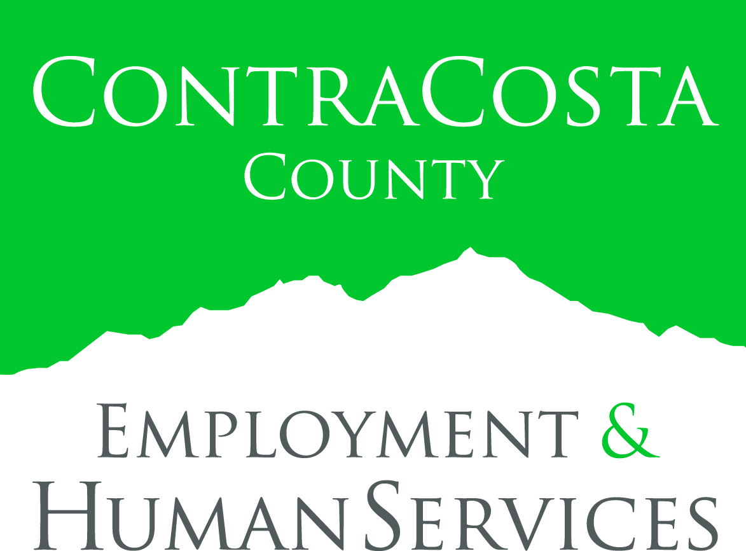

FOR IMMEDIATE RELEASE:
EHSD Aging & Adult Services Awarded $1.5 Million in Grants to Respond to Elder Abuse as Contra Costa County’s Aging Population Grows
OES Funding to Support Multi-disciplinary Approach, Forensic Death Review, Outreach and Training to Deal with Senior Abuse, Neglect, Abandonment and Isolation
MARTINEZ, Calif. (August 15, 2016) – Contra Costa County Employment & Human Services Department (EHSD) has announced that its Aging and Adult Services (AAS) bureau has been awarded two grants totaling $1.5 million from the California Governor’s Office of Emergency Services (Cal OES). AAS will use the funding awards to focus on addressing the issue of elder abuse, a critical concern as the county’s aging population continues to grow while seniors are also facing an array of social and health challenges. AAS is already implementing the Cal OES grant awards through Adult Protective Services (APS), and anticipates all services and supports for seniors will be fully in place by October, 2016.
“Adult Protective Services is on the front lines of responding to elders who are at risk of being abused or neglected,” explained Victoria Tolbert, EHSD director of Aging & Adult Services. “As family members, friends, neighbors and caregivers become better educated to recognize the signs of abuse, we are seeing even more reports coming into the department. We are thrilled that the Cal OES grants will significantly enhance our ability to deal with this increase as well as support a multidisciplinary approach to improving services and outcomes for seniors.”
The overall number of abuse reports has risen from 3,115 during the 2013/2014 fiscal year to 4,484 in 2014/2015, representing a 30 percent increase in the number of calls to APS in Contra Costa County. Furthermore, the complexities of cases call for the combined expertise of law enforcement, behavioral health, health care and social services in order to better address the needs of the elderly.
The first Cal OES grant in the amount of $400,000 with an EHSD match of $100,000 enables the establishment of a multi-disciplinary team to engage all APS client systems serving elders in case examination, documentation and training in order to improve outcomes for victims of abuse and neglect. In addition, the grant will allow for the development of a forensic death review process to examine the circumstances of suspicious senior deaths in the county and identify any gaps in service and potential changes to address them.
An Adult and Aging trainer will be dedicated to developing training materials for community partners, as well as baseline training for AAS staff. An elder abuse victim specialist will focus on creating the forensic death review and case examination processes, and formalizing the multi-disciplinary team. The grant will also enable APS to better assist seniors with urgent needs such as adult diapers, nutritional shakes, blankets, grab bars and more, and a public health nurse will assist the APS worker in identifying immediate health needs and recommending solutions. The outreach component includes providing education tools for law enforcement and the general public to improve the community’s ability to recognize the signs of elder abuse and to respond in a way that helps ensure the safety and well-being of seniors.
The second Cal OES grant awards $957,000 with an EHSD match of $250,000 to support APS’ partnerships with several key providers in order to jointly handle financial abuse cases and expand the multi-disciplinary approach to form a veritable Forensic Center. The purpose of this collaboration is to deepen investigations and strengthen support services and protective actions for abused elders. EHSD put forth the required cash match with community partners dedicating significant in-kind resources and full commitment to the effort.
Forensic Center partners include Contra Costa County Office of the Sheriff; Contra Costa Health Services Conservatorship/Guardianship Program; Contra Costa Regional Medical Center Mental Health/Psychiatry; Contra Costa Behavioral Health Services Older Adult Mental Health Services; Ombudsman Services of Contra Costa; Zero Tolerance for Domestic Violence Initiative; Office of the District Attorney Contra Costa County; Meals on Wheels and the Family Justice Center.
The Cal OES grants are part of a statewide program/initiative to prevent elder abuse and assist those impacted by it.
Aging and Adult Services
EHSD Aging and Adult Services (AAS) is dedicated to the safety and well-being of Contra Costa County’s elders and persons with disabilities. AAS operates a variety of programs designed to allow individuals to safely remain in their own homes and to thrive with dignity, including Adult Protective Services (APS) which responds to confidential reports from anyone who suspects that an elderly person or an adult with a disability (dependent adult) who lives in Contra Costa County is being abused or neglected or is self-neglecting. A 24-hour hotline is staffed by social workers who respond to these calls and walk the caller through a series of questions to determine if a situation requires APS intervention. When a case is opened in APS, an APS social worker is assigned to the case and visits the home of the alleged victim to determine what services, if any, are needed.
Contra Costa County Employment & Human Services
Employment & Human Services (EHSD) partners with the community to deliver quality services to ensure access to resources that support, protect, and empower individuals and families to achieve self-sufficiency. Based on the core values of delivering an exceptional customer experience, encouraging open communication, embracing change, practicing ethical behavior, and embracing diversity, EHSD envisions Contra Costa County will continue to be a thriving community where all individuals and families can be healthy, safe, secure and self-sufficient. More information about EHSD is available at www.ehsd.org.
# # #
Media contact:
Tish Gallegos, Community/Media Relations
(925) 313-1779 or (925) 433-1266
tgallegos@ehsd.cccounty.us
www.ehsd.org

